NAME:Rishik JK
REG.NO :192511052

CSA1702-ARTIFICIAL INTELLIGENCE
LAB EXPERIMENT

19. Prolog Program for Student-Teacher-Subject Code

1. Aim
To write a Prolog program to create a database containing student names, teacher names and subject codes, and retrieve the related details.

2. Algorithm
- Start the program.
- Create a database using student, teacher and subject code.
- Store the student name, teacher name and subject code.
- Define a rule to retrieve the details
- Give the student name as input.
- Display the teacher name and subject code.
- Stop the program.
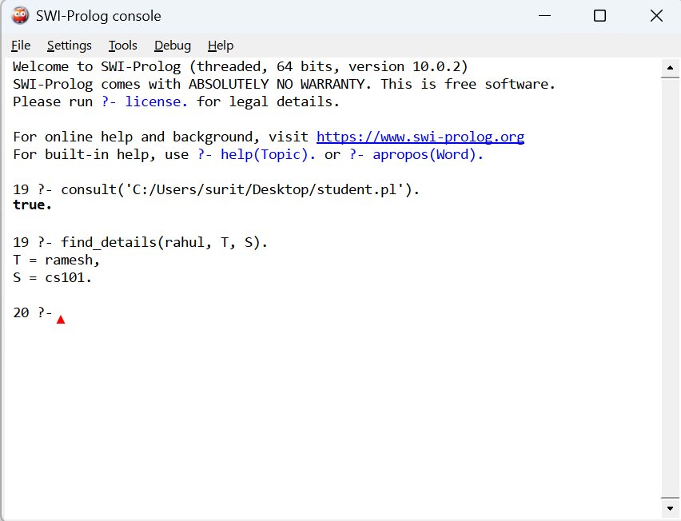

Result
Thus, the Prolog program to create a database containing student names, teacher names and subject codes was successfully implemented and executed. The corresponding teacher name and subject code were retrieved successfully for the given student.

